ADDITIONAL GM TOOLS

In this section you’ll find a selection of system-neutral GM tools for buffing up particular parts of your creations. None of them are strictly necessary, but they might save you a little grief when it comes time to flesh out an NPC or establish some visual identity for a lost city.

Readers interested in more tools of this kind are ad­vised to pick up at least the free versions of Sine Nomine Publishing’s ***Stars Without Number*** and ***Godbound*** role playing games, as both of them contain extensive GM helps in this vein. Most of the rest of the current Sine Nomine catalog also consists of largely system-neu­tral GM tools and helps that could be used by almost any creator in need of a little extra boost.

d10 Bait for Adventure Hooks

1. Direct payment from a specific patron
2. The assurance of rich loot yet unplundered
3. Revenge against a foe the party hates
4. Help given to a sympathetic figure or friend
5. A magical item that they would prize
6. Occult lore and spells useful to mages
7. Ancient salvage for skilled mod-crafters
8. Escape from some looming calamity or foe
9. Fame and the admiration of others
10. Curiosity and learning of the unknown

d20 Ways of Introducing an Adventure Hook

1. Note or map on a defeated foe
2. Overheard market gossip or tavern talk
3. Sad tale of a survivor or escapee
4. Text found while exploring
5. Divine omen or magical disturbance
6. Former patron seeking them out
7. Desperate local looking for help with it
8. A plotter mistakes them for confederates
9. Encounter a place scarred by the adventure **10** Fight a monster made to flee from the site **11** Find a treasure with embedded information **12** Be hired by the antagonist as muscle **13** A friend of the party is affected by it **14** Town crier announces it in public **15** They stumble into an active part of it

**16** Intercept a message meant for an antagonist **17** Government official needs to hire help **18** Failed first group tries to pass along the job **19** Plea for help nailed up in public **20** Guild or business looking for hired help

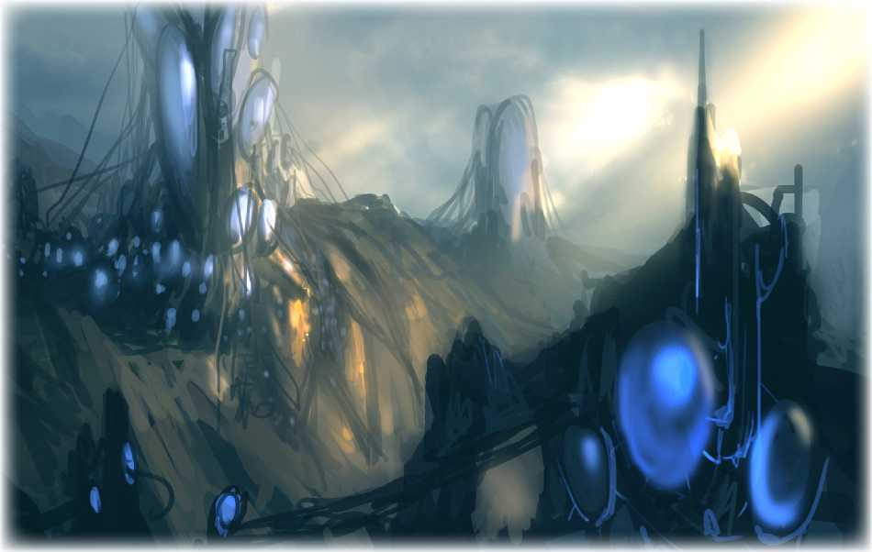

Oracular Adventure Adjustments

A GM is often dubious about their own creations; they have the general thread of an idea but they aren’t certain it’s the *right* idea. Sometimes they’re confronted with a concept or a twist that’s attractive, but just not quite right.

These tables offer some randomized prompts for sit­uations, NPCs, or just general adventure and campaign ideas. When you hit a block in your creations or want to spice up a too-bland adventure outline, pick one or more of the tables and roll or choose from the results to twist an adventure element, get an oracular assessment of an adventure fact, or throw in a random event that might complicate the plans of both heroes and antagonists. When adding these twists, however, take care that they don’t have too many assumptions about PC responses or fix outcomes as inevitable despite PC involvement.

d6 This Mistake Twists the Adventure

1. An NPC dies naturally at the worst time
2. An NPC fails at what they normally excel at
3. A fundamental premise is in error
4. The PCs are handed secrets from the start
5. The wrong people fall in love or hate
6. The NPC’s scheme was doomed at the start

d4 Idea Affirmation or Negation

1. No; it’s the opposite, or totally unrelated
2. No; it’s related but different
3. Yes; but one of your assumptions is wrong
4. Yes; in fact, you should push it even farther

d 12 How Do I Change This NPC?

**1** Split them into more than one person

**2** Flip an antagonist into an ally, or vice-versa

**3** Make them deeply unsympathetic

**4** Make them mistaken about an important fact **5** Make them strangely capable or strong

**6** They’re there because of a thing the PCs did **7** Give them a glaringly obvious character flaw **8** Make them friends with an unexpected figure **9** Put them in an unexpected setting or locale **10** Give them a new reason to want something **11** Magically bless or curse them

**12** Make them a demi- or non-human

| **d8** | **This Theme Informs the Adventure** |
| --- | --- |
| **1** | Pride, the refusal to admit error or weakness |
| **2** | Ignorance, lacking critical knowledge |
| **3** | Greed and the craving for wealth |
| **4** | Revenge and the cyclical cost of it |
| **5** | Idealism and its triumph or bitter failure |
| **6** | Natural consequences, cold and indifferent |
| **7** | Desire for love, friendship, or other passions |
| **8** | Duty and the grim obligations it lays on |
| **d10** | **This Reality Intrudes Into the Situation** |
| **1** | Someone’s too poor for a vital necessity |
| **2** | Someone isn’t as good as they think they are |
| **3** | A trusted relationship proves uncertain |
| **4** | A cherished dream is simply impossible |
| **5** | A grand ideal proves to be unworkable |
| **6** | Someone’s self-image is totally inaccurate |
| **7** | Someone angered the gods or spirits |
| **8** | An old crime must now be paid for |
| **9** | Someone gives up in the face of hardship |
| **10** | A natural disaster or weather interferes |

Throw This Event Into the Adventure

**d20**

1. An arsonist sets something ablaze
2. Someone gets a dangerous sickness
3. A thief robs someone involved
4. An unrelated enemy strikes at someone
5. Blighted raiders or bandits attack
6. A noble somehow gets in the way of things
7. A wizard did it, whatever it is
8. The PCs are mistakenly accused of something
9. Calamitously bad or troublesome weather
10. An enemy group attacks a nearby place
11. The PCs are caught in the crossfire of a fight
12. Something ancient finally collapses or breaks
13. Earthquake, disease outbreak, or wildfire
14. Disaster strikes the local rulers
15. An important local faith gets mad at a thing
16. An ally of the PCs makes a very bad move
17. Civil unrest makes problems
18. A sudden shortage of a vital good or service
19. A religious festival somehow gets in the way
20. The antagonist makes a grave mistake